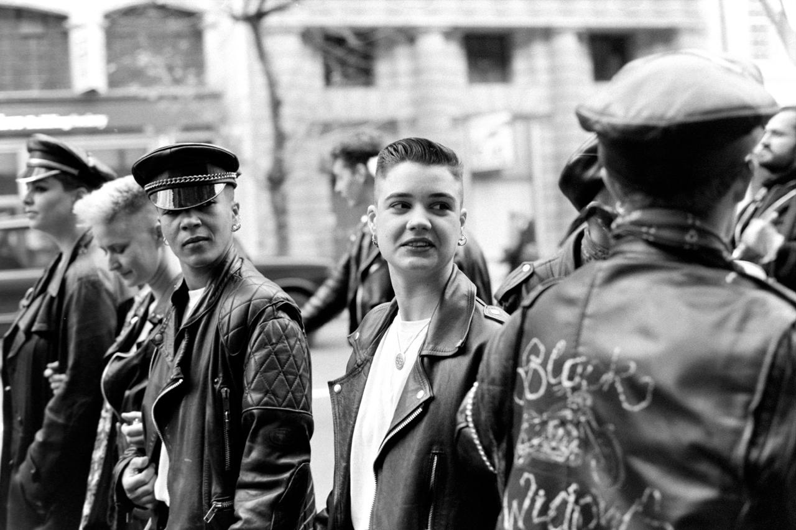

Mutilation anthology:

102)
You love me and
now you’re dishonest.
The mask of indifference stopped your sugar lies
Worn so long FusedFlesh burnt truth.

Cigarette blistered mouth.

The last person you dated you thought you would marry.
I sleep in the grave
of a girl I’ve never met.

She gave you the mask. At first you wore it with pride
But soon it closed around your mouth,

tattooed wire wrapped around your throat

Blood coated vulnerability

Clots of bile soak,
‘I love you’
I clean them, keep them, collect them.

The mask still lives but looser now
Dislodged by salt water from people who came TooClose.

I stay gripping ripped skin
Hoping sticky sweet fingers are enough to hold you still.
My hands are not surgical,
my knife is rusty.
But I will remove the mask-
you can kick and scream

This cold grave will freeze me
And I Want Out.

97)

I once had purpose.
I was the secret keeper, I was the information
Never flew to close to the sun,
Never wished for more.

I was the power and the shrapnel on battlefields -
A created mutant, rejected and honest.
You, delighted in my presence
from lovers, sisters, mothers, enemies or whores.

I was the secret keeper with bleeding vocal cords.
Rolling my Rs and screeching into choking smoke,
cooing at babies as I told the world of their arrival

But now I don’t even serve as a reminder of the past-
your blade hair slices my feet to stumps.
I limp near the now grown baby,
She kicks, but not how she had once kicked her mother

My skin is dry and my knees bleed, just like yours
I live off the scraps you leave. -Always leaving-
You left me, but never truly freed me.
You won’t even eat me.

My cousin a sign of hope and purity,
But she had the good fortune to be loved by god
and yet you shoot clay versions of me

you condemned me the rat of the sky,
weighed down by my war medals
so I can’t even fly properly.

99)
Skin of wet tissue paper,
Thick veins
Protruding
under.
Blood pulsing through, s l o w e r and s l o w e r

always alone, always two cups of tea, one always goes cold.
Age softened skin surrounding harsh eyes,

Legs left to go stiff.
Scared of the
height of her head
faces she raised being strangers in her room

coral lipstick seeping into the cracks of her skin-
she doesn’t know she’s the matriarch
with a mutilated brain-
a cigarette forgotten burning paper skin.
Voice loud but soft words
A change from the mother she once was.

but she doesn’t know her children.

We sit in a room.
smoke covered walls, two metal mugs dust-coated windows
We have never known each other.

She’s a tissue paper shell with a time travelling brain
and I was born too late to know the stories

the past is the present for her.

96)

Window held open with a bible-
Splintered floorboards under fluffy socks
Primark pyjamas, pink pyjamas, piglet pyjamas
A child’s chair.
Tits she shouldn’t have yet, stretching the cotton
knees too high up, wet hair,

cigarettes
Specifically dog ends all rolled into one-
Chapped lips
Burnt fingertips
mums watching.
Nothing present but eyes and a shadow-
Another swig of whisky-

radiator blistering elbows, an easily explained selfharm.
Eyes water,
Train goes,
Windows rattle-
bible slips, it always does eventually.
Whispers promises of salvation,

Hymns and flesh torn-
Cigarette still lit,
Another drag of dry smoke,

nothing moves-
eyes still water.
eyes still watch.

98)

I’ve never spoken to anyone about this.
Which is unheard of for me, considering I never shut the fuck up
I even talk in my sleep.
I worry my ankles are too skinny to carry my bag of flesh
That one day they will give out, snap under me
Its not unheard of, bones crack under pressure all the time

I’ve broken stuff before
Both legs
Both arms
All my fingers
And toes
My skull
My sternum
I’m no stranger to distrusting my bones

When you’re little you’re told that they are stronger when they mend-
Like you should be proud.
Like breaking yourself to create a stronger mutant is a medal of honour
When you get slightly older they ask
‘why do you play so rough?’
Like I shouldn’t still be proud that I’m creating the perfect weapon-
Now I’m even older
All my joints move janky, like a puppet on strings
And all my steps are slow, calculated.

I always wear boots
To stop the breeze from slicing my ligaments
My ankles shortbread,
Flaking. crumbling under my muscles
Splintering like chip shop forks under my weight.

I starve myself so I had to eat my bone marrow.
I cut myself to chew on my muscles.
I pull myself to rip my tendons.
I gauge out my eyes to drink the vinegar inside-
I enjoy it all, I have to. My ankles need to be remade. I couldn’t do it right the first time.

My ankles are to brittle to hold my empty bones
My bitten muscles
My sandpaper tendons

I must be remade. Remade in gods image

104)
wasn’t there
A history that came
and went,
Her. Immortal in negatives and film-
my mum was there.

Not my blood- but looked in the eye,
greyscale politics, sharp tongue
Because they had to.

Film camera captured negatives,
camera contact lenses-
Iris of the Past.

Name unknown-
but I would have been a period without her-
Clotted blood in lace knickers,
a control of private lives,
Velvet Curtains Closed
LegsForcedClosed
Tender breast masked by leather.
Toughen your skin-
You’re going to need it.

‘The pen is mightier than the sword’
Holds value until
people throw knives-
Cutting the skin, cracking our skulls.
Aim at the crowd. They shout.
It’s harder to hit scattered bones.
The mass of limbs, an aching target.

Cut out my eyes
I don’t want to see
would be Mothers watching
More life in them
Slash back with hate
Blood will fertilize the concrete.

Watching one another,
history forgotten, rewritten-
Captured fleshy underbellies
from within.

100)
Your face aged by screen light
Sunken cheeks, hollow eyes and gritted teeth
Gone before morning.
where do you sleep?

When you left, you left a draw
Completely forgotten,
the one at the bottom.
did you not have time-?
when you packed that night?
One bag, along with my childhood.

Three T-shirts, worn thin, layers of skin
Left for me to toughen mine
Pulled tight like fresh scabs.
Gone before sleep left
did it ever truly come back after?
did you pack it in your one bag?

T-shirt smuggled under childhood sheets,
Everything burnt bar my contraband-
Fabric blistered into my skin, I need to remember you.
I need the flesh you left behind-

Filled your bag with my memories and left
Robbed of the things I could have said to you-
Ripped your hand away and left mine scarred-
Lived your life, mother hidden identity
Identity theft of the mum I knew.

Seeing it, knowing it happened
But not remembering
The photo was fake when it was taken.
smiles don’t reach their wet eyes, blotchy cheeks
my smile contorted, hasn’t learnt to perform yet
She will, but I won’t remember.

born at 13, that’s the life I know
Childhood packed in the bag you took
A life before you packed your bag
One I will never know-

have the bruises stayed with me?
I don’t think you took them
are they mine now?

